“E - COMMERCE WEBSITE”

on school accessories.



### *Abstract*—•The main aim of this project is to easy life of students, parents and schools / colleges at the time of reopening by using a simple E - commerce Website. This Website allow users to purchase all school accessories (ex: uniforms, tie, belt, shoes, socks, books etc..) of a particular school through online.

* **It consists of different sections or categories for easy access and we can select size of product. This website provides discount on all products 24/7 days. This website is completely responsive and dynamic**

***Keywords—E-commerce, dynamic, responsive***

**INTRODUCTION**

A website that allows people to buy and sell physical goods, services, and digital products over the internet rather than at a brick-and-mortar location. Through an e-commerce website, a business can process orders, accept payments, manage shipping and logistics, and provide customer service. An e-commerce website is one that allows people to buy and sell physical goods, services, and digital products over the internet rather than at a brick-and-mortar location. Through an e- commerce website, a business can process orders, accept payments, manage shipping and logistics, and provide customer service. It’s tough to imagine daily life without e-commerce. We order food, clothes, and furniture; we register for classes and other online services; we download books, music, and movies; and so much more. E-commerce has taken root and is here to stay. The term “e-commerce” simply means the sale of goods or services on the internet. In its most basic form, e-commerce involves electronically transferring funds and data between 2 or more parties.

**I. LITERATURE SURVEY**

## The architecture of the existing system was basically manual oriented. The system was initially developed to cater for the products in the business area. The system was dimmed efficient during the initial stage of its establishment. The system caters for all the products owned by the business man. The objectives of the system were borne out of the fact that, business man cannot exhaustively make his products visible to his clients; therefore there is a need for the clients to search for more information of his products and services. We conducted a thorough literature survey by reviewing existing system i.e, hirawats online store and we took it as a reference to our project. We conducted an offline Literature survey where we meet few parents and school students and took their feedbacks. We also visited some nearby schools and we took information of school uniforms form school management. By the help of this literature survey, we developed this project

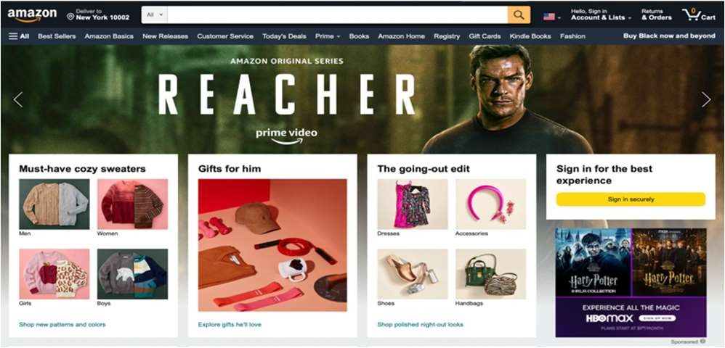

**II. EXISTING SYSTEM**

The architecture of the existing system was basically manual oriented. The system was initially developed to cater for the products in the business area. The system was dimmed efficient during the initial stage of its establishment. The system caters for all the products owned by the business man. The objectives of the system were borne out of the fact that, business man cannot exhaustively make his products visible to clients. There is a need for the clients to search setting someone to visit your e-commerce website is a great first step, but you still need to keep them interested and motivate them to make an order. Calls to action (CTAs) are critical when it comes to directing user actions and optimizing the customer experience.

**III. PROPOSED SYSTEM**

The main aim of this project is to easy life of student, parents and schools/ colleges at the time of reopening by using a simple E-commerce website. This website allows users to purchase all school accessories like uniforms, ties, belt, shoes, socks, books and etc. At present we are just dealing with school uniforms later we will add all the above mentioned accessories.

**3.2. OBJECTIVES OF PROPOSED SYSTE**

The objectives of the proposed system include the following

* + - It consists of different sections or categories for easy access and we can select size of product.
    - This website is completely responsive and dynamic
    - It is a 24/7 online website

**IV. IMPLEMENTATION STEPS**

### SYSTEM DESIGN

**COMPONENTS OR USERS IN THE PROPOSED SYSTEM**

1. **Easy Navigation**

There’s nothing wrong with having a unique e-commerce design, but too much change can backfire by making your site less approachable. The ease of the customer experience should be one of your top priorities throughout the design process. Amazon is the most powerful e-commerce platform in the world, and it’s an ideal example of an approachable e-commerce design. At the top of the screen is a basic search bar, plus other information and settings such as the visitor’s location, cart, and account. A few simple issues with checkout can have a consistent impact on sales. One simple way to ensure a higher conversion rate is to make sure that users keep a persistent cart across multiple visits. If a visitor adds something to their cart, it should still be there the next time they come back to your site. Without a persistent cart, they’ll have to find the product a second time and put it back in their cart to initiate checkout.

1. **Mobile Optimization**

Only five or 10 years ago, mobile e-commerce sales were a distant second to orders placed on a desktop or laptop. Today, more and more purchases are being made through smartphones and tablets, making mobile engagement one of the top e-commerce trends for 2022.

If your e-commerce design doesn’t work as well on smaller screens, you’re likely losing a substantial number of potential sales. For example, text in images may be perfectly legible on a computer, but too small for users to read if they’re visiting on their phone.

1. **Checkout**

If a user makes it to your checkout sequence, you’ve done almost all of the work involved in making the sale. The last thing you want is for inefficiencies or technical issues to push them away at the last moment.

A few simple issues with checkout can have a consistent impact on sales. One simple way to ensure a higher conversion rate is to make sure that users keep a persistent cart across multiple visits. If a visitor adds something to their cart, it should still be there the next time they come back to your site. Without a persistent cart, they’ll have to find the product a second time and put it back in their cart to initiate checkout.

**4. Customer Support**

Your website design should minimize uncertainty and confusion but users may still have questions or concerns that they can’t find an answer for. In these situations, it’s important to give them easy access to help from your customer support team. Customer support is one of the most commonly underestimated aspects of e-commerce sales, particularly for growing stores. Answering customer questions quickly helps them overcome their concerns and gain more confidence in your brand and products.

**5. Shipping and Return Information**

On top of the products themselves, customers may also have

questions about your shipping policies or rules about returns and exchanges. If you withhold this information until they get into checkout, it comes as a surprise and potentially leads to a lost sale.

**6. Calls to Action**

Getting someone to visit your e-commerce website is a great first

step, but you still need to keep them interested and motivate them

to make an order. Calls to action (CTAs) are critical when it comes

to directing user actions and optimizing the customer experience.

One of the simplest ways to engage with website visitors

is to get their contact information. Even if they don’t

make a purchase during their first visit, you’ll be able

to contact them later on and potentially bring them

back to your site.

**Customer Support**

Your website design should minimize uncertainty and confusion, but users may still have questions or concerns that they can’t find an answer for. In these situations, it’s important to give them easy access to help from your customer support team.

Customer support is one of the most commonly underestimated aspects of e-commerce sales, particularly for growing stores. Answering customer questions quickly helps them overcome their concerns and gain more confidence in your brand and products

* + - 1. **Shipping and Return Information**

On top of the products themselves, customers may also have questions about your shipping policies or rules about returns and exchanges. If you withhold this information until they get into checkout, it comes as a surprise and potentially leads to a lost sale.

* + - 1. **Calls to Action**

## 

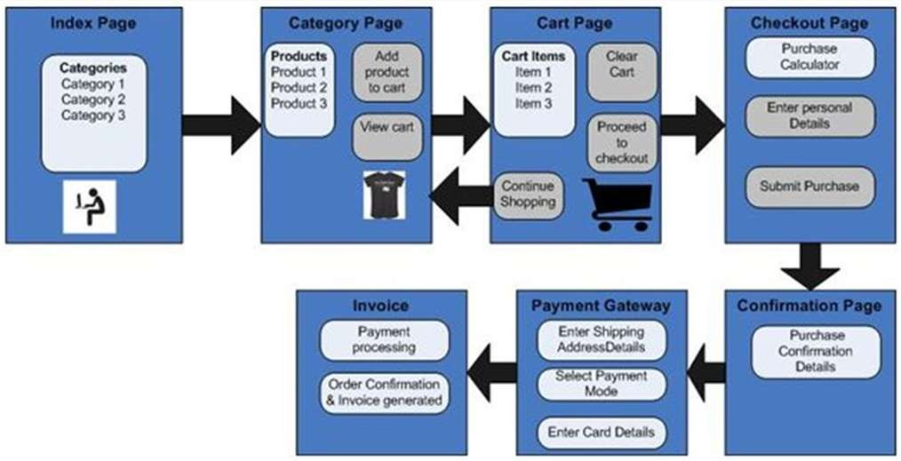

One of the simplest ways to engage with website visitors is to get their contact information. Even if they don’t make a purchase during their first visit, you’ll be able to contact them later on and potentially bring them back to your site.

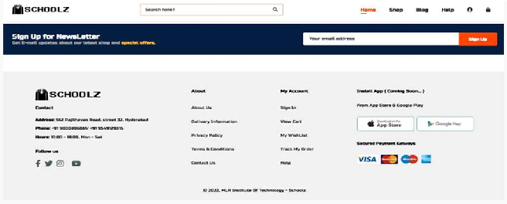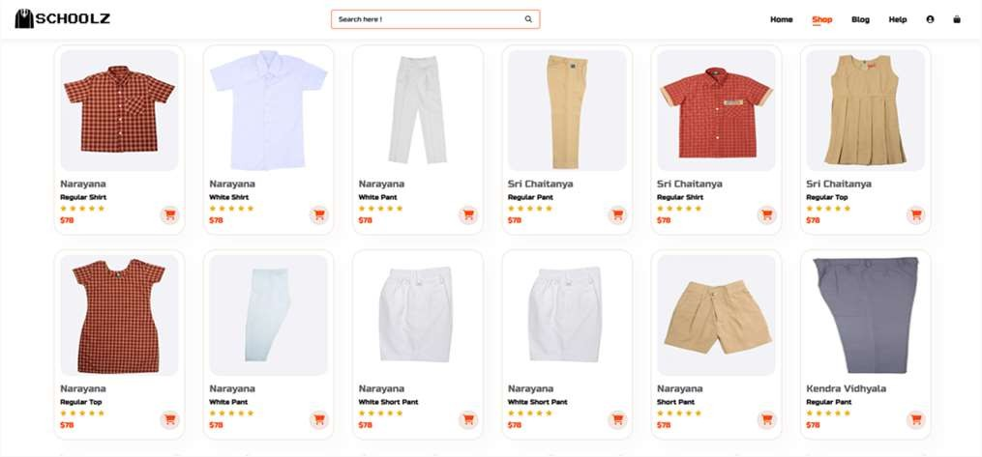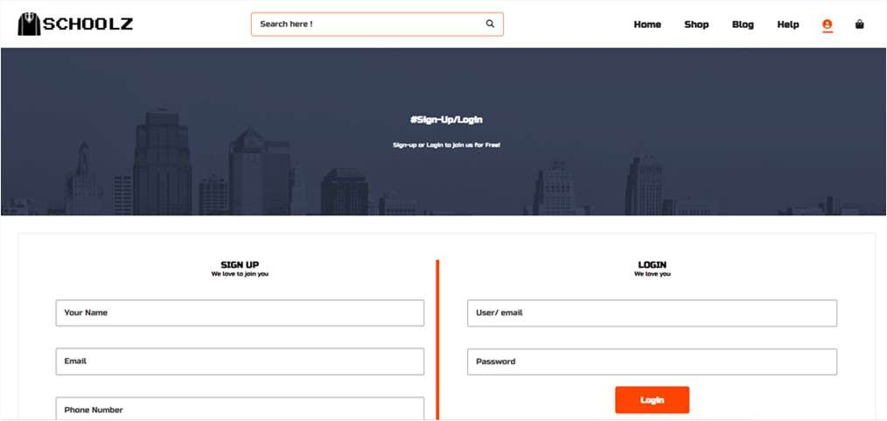

* 1. CONCLUSION

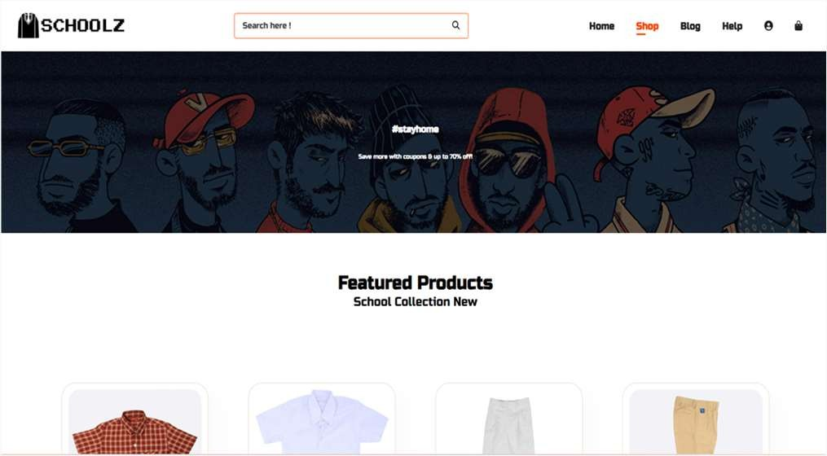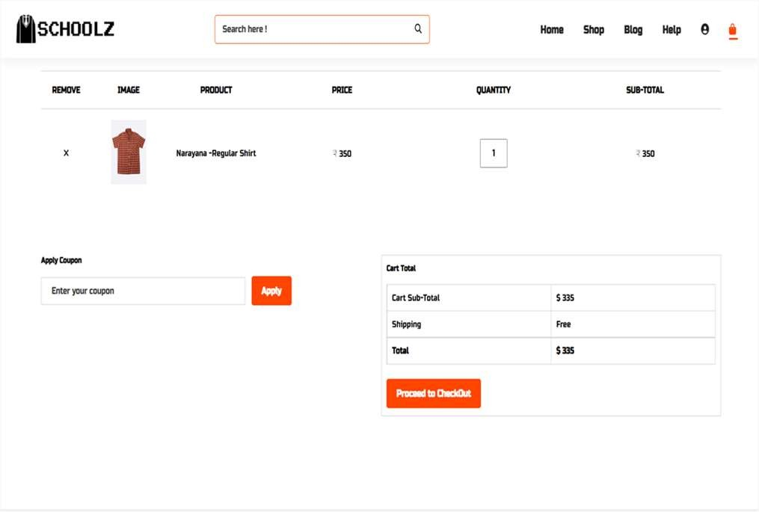

Result:

**We are thinking of modifications and adding some advanced new features in out system. Some of them are –**

# App

1. **Users can sell their products**

# Users can signup / login using their social media handles like Facebook, Google etc.

* 1. **ACKNOWLEDGMENT**

## The satisfaction and euphoria that accompany the successful completion of any task would be incomplete without the mention of people who made it possible, whose constant guidance and encouragement crowned our efforts with success. It is a pleasant aspect that we have now the opportunity to express our gratitude for all of them.

First of all we would like to express our deep gratitude towards our internal guide **Mrs Ragini Patel, Assistant Professor,** Department of CSE for her support in the

completion of our dissertation. We wish to express our sincere thanks to **Prof. Anupriya, Dept. of CSE** and principal **Dr. K.SRINIVAS RAO** for providing the facilities to complete the dissertation.

## We are thankful to **Mr. M. RAJASHEKAR REDDY** Secretary of MLR Institute of Technology for accepting us and providing us with an opportunity to do a project in their esteemed organization.

We would like to thank all our faculty and friends for their help and constructive criticism during the project period. Finally, we are very much indebted to our parents for their moral support and encouragement to achieve our goals.

REFERENCES

**https://**[**www.w3schools.com/html/**](http://www.w3schools.com/html/) **https://**[**www.hirawatsonline.com/**](http://www.hirawatsonline.com/) **https://**[**www.w3schools.com/CSS/**](http://www.w3schools.com/CSS/) **https://**[**www.w3schools.com/JAVA/**](http://www.w3schools.com/JAVA/)